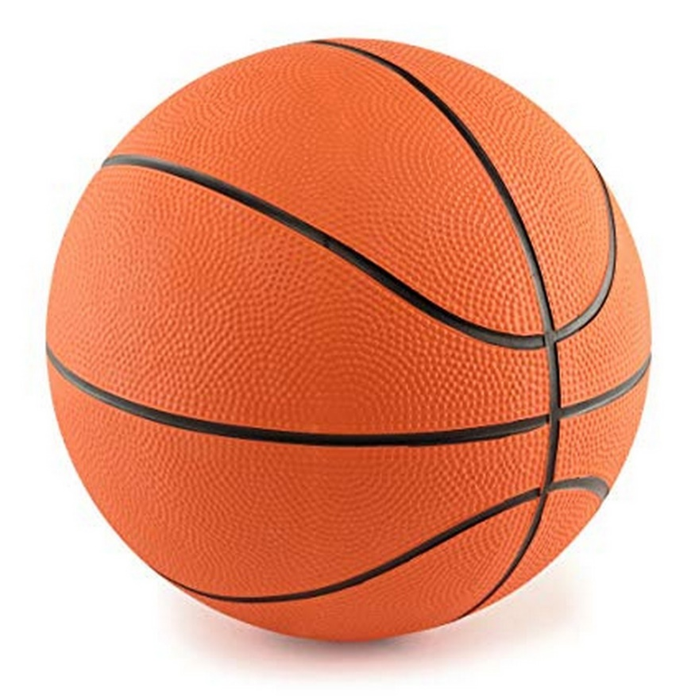

**Basket Ball orange colour**

Rs. 849

~~Rs. 999~~-15%

* Size: Standard
* Rubber Manufactured Basketball
* Enjoy your favorite sports game with this ball